Using Four in a Row for Math Fact Fluency:
- Derived Fact Strategy Game for Addition
- Targeted Facts: Sums within 20
- Once students have automaticity with foundational facts, they are ready to find any addition or subtraction fact within 20, using a derived fact strategy.
- Near Doubles, Making 10, and Pretend a Ten are accessible, commonly used, and powerful strategies students may use during Four In A Row.
About Games and Math Fact Fluency:
Games are fun. But, more importantly, games are effective ways to support learning. Games provide opportunities for:
- low-stress practice of (1) facts and (2) strategies (both outcomes are critical to math beyond the basic facts!).
- think aloud, an effective learning strategy. Therefore, students should develop the habit of verbalizing their mathematical thinking out loud.
- student listening and learning from peers. Therefore, discussing strategies before and after playing allows students opportunities to learn from each other.
- teachers to formatively assess and plan instruction. Therefore, at times, use an observation tool to record how students are progressing.
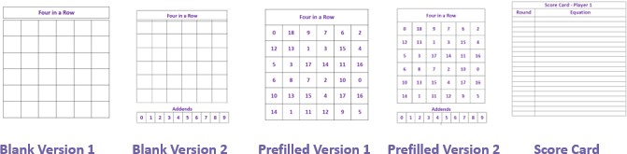
Effective math fact fluency games remove time pressure and allow students time to think. That means no time component. Each player has their own cards or dice to roll, so they are not racing each other. Scoring is de-emphasized. Thinking strategies are front and center.
Four in a Row
2 players
Materials: One game board shared by 2 students (choose one of the blank versions for students to
fill in, or use a prefilled version), a Score Card for each student, counters in two colors (different color for each player), and playing cards with Kings and Jacks removed (ace = 1; queen = 0).

Four in a Row 2 players

How to Play Version 1:
- Players write the numbers 0-18 randomly in each square of the shared game board.
Each number need not be used. Each number may be used more than once.
- Shuffle the cards and place them in the center of the players.
- Player 1 draws two cards and calculates the sum. Player 1 states the answer and shares the thinking strategy used.
- Both players decide if the sum is correct. Once they agree it is correct, Player 1 records the equation on their score card.
- If the number appears on the game board, player 1 covers it with a counter. Only one square may be covered on each turn, and a counter cannot be moved once played.
- Repeat steps 3-5 for Player 2.
- Play continues until someone gets four in a row.
How to Play Version 2:
- Players write the numbers 0-18 randomly in each square of the game board.
Each number need not be used. Each number may be used more than once.
- Player 1 begins play by placing markers on two numbers in the row of addends.
- Player 1 calculates the sum of the two numbers. Player 1 states the answer and shares the thinking strategy used.
- Both players decide if the sum is correct.
- If the sum appears on the players’ game board, player 1 covers it with a counter. Only one square may be covered on each turn, and a counter cannot be moved once played.
- Player 1’s turn has ended.
- Player 2 moves only one of the counters on the row of addends.
- Player 2 calculates the sum of the two numbers. Player 2 states the answer and shares the thinking strategy used.
- Both players decide if the sum is correct.
- If the sum appears on the players’ game board, player 2 covers it with a counter. Only one square may be covered on each turn, and a counter cannot be moved once played.
- Repeat steps 7-10 for Player 1.
- Players continue to take turns, trying to build four in a row in their own color (or trying to block their opponent from getting four in a row).
- The first player to get four in a row wins the game.

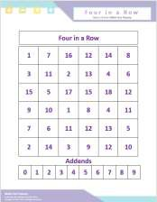
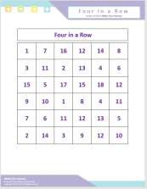
Four in a Row 2 players
Game in Action:
I am going to add 1 to 9 to make 10 and take 1 away from 7 to make 6.
10 + 6 = 16. I get to cover 16!

Version 1

The markers are on 5 and 6.
I am going to move the marker off 5 and place it on 2. 6 plus 2 equals 8. I get to move my chip to 8 to block!

Version 2

